**The high level design of a book inventory**

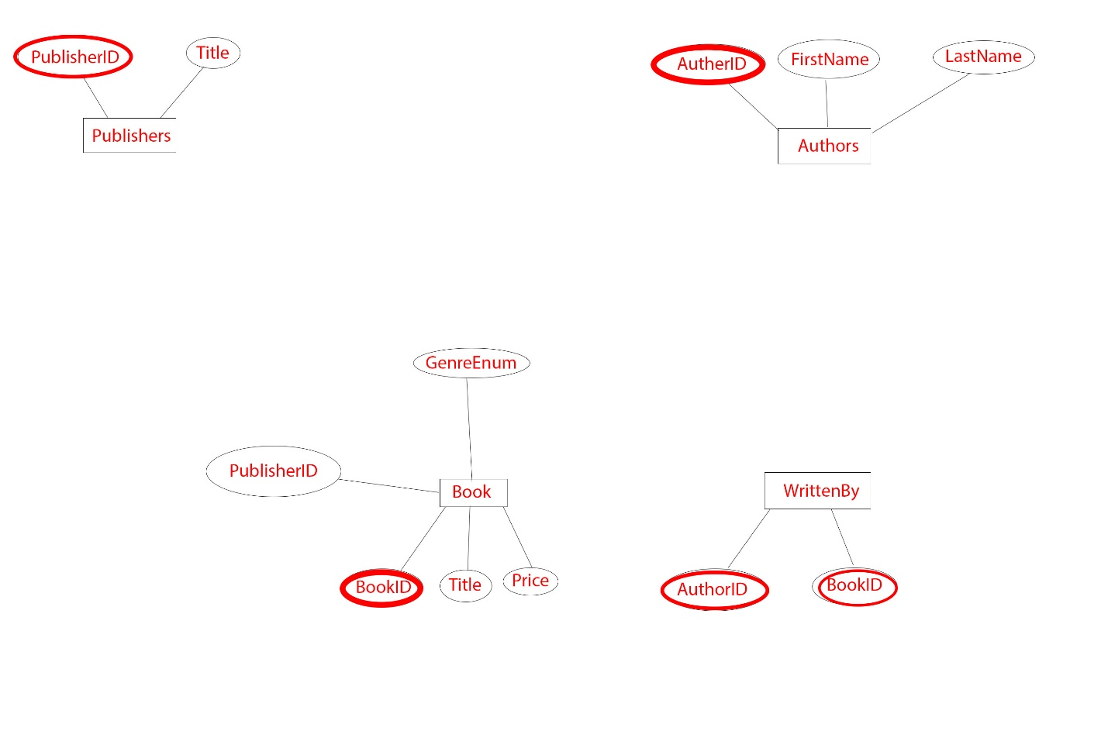

We would create for tables one for Books, Publishers, Authors and also another table to maintain the man to many relationship between the books and the authors. The Genre can be defined as an enum instead of creating another table for it since it is only a string and doesn’t need any extra details.

The primary keys are drawn in red.

A book is published by only one publisher so we wouldn’t need an extra table to describe their one to many relationship but regarding the authors of a but since a book can have multiple authors and an author can write multiple books in his name, they would have a many to many relationship so we would need an extra table to describe their many to many relationship. And the primary key of the table would be declared by joining its two columns since they are both unique in their own table and so joining them together in a single table would be unique.

I have used stored procedures without the need of creating and sending query strings to the database. The store procedure receives two parameters one is the column which has to perform the search on and the second it’s the value which is searching for that column:

create or alter procedure BooksSearch

@columnName nvarchar(255),

@value nvarchar(255)

as

begin

declare @Sql nvarchar(max)

set @Sql = 'Select * from Books where '+@columnName+' like ''%'+@value+'%'''

exec sp_executesql @Sql

end;